Waterproof Spot Light

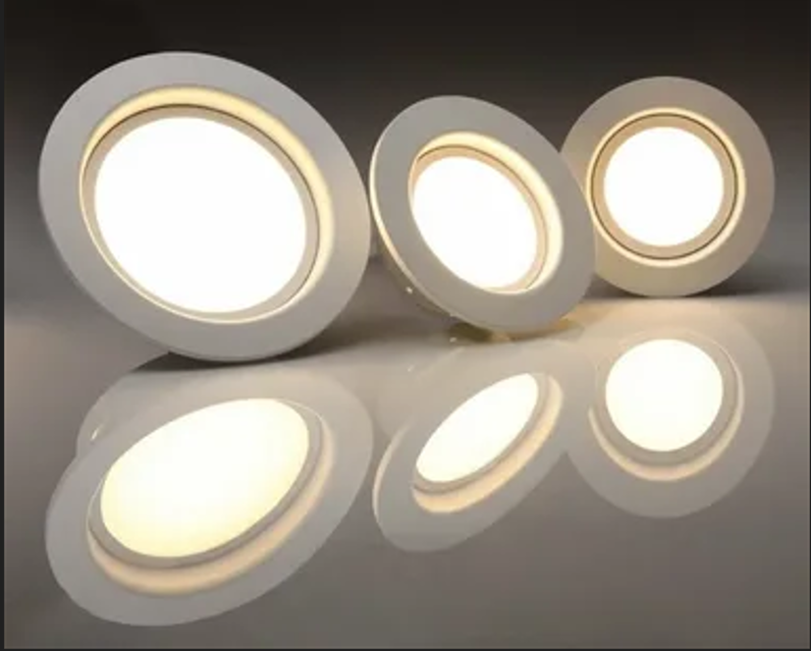

#### ****Description:****

**Waterproof Spot Lights** are durable, energy-efficient lighting solutions designed to provide focused and directional light for outdoor and wet environments. These lights are perfect for illuminating gardens, pathways, driveways, and outdoor decor. With a weather-resistant design and adjustable heads, Waterproof Spot Lights offer both functionality and style.

* **Technology:** LED.
* **Compatibility:** Standard E26/E27 base (fits most fixtures).
* **Bulb Type:** Integrated LED (non-replaceable).
* **Wattage:** 10W (equivalent to 75W incandescent), 20W (equivalent to 150W incandescent).
* **Lumens:** 800 lumens (10W), 1600 lumens (20W).
* **Color Temperature:** 2700K (warm white), 3000K (soft white), 4000K (cool white).
* **Dimmable:** Yes (select models).
* **Lifespan:** 50,000 hours.
* **Energy Efficiency:** Energy Star certified.
* **Weather Resistance:** IP65 rated (dust-tight and protected against water jets).

#### ****Key Features:****

* **Weather-Resistant:** Designed to withstand rain, snow, and extreme temperatures.
* **Energy-Efficient:** Uses up to 85% less energy than traditional incandescent bulbs.
* **Focused Lighting:** Ideal for highlighting garden features, pathways, and outdoor decor.
* **Dimmable Options:** Available in dimmable models for adjustable brightness.
* **Long Lifespan:** Lasts up to 50,000 hours, reducing the need for frequent replacements.
* **Adjustable Heads:** Allows you to direct light precisely where it’s needed.
* **Easy Installation:** Designed for simple mounting with included hardware.

#### ****Pricing:****

* **Single Waterproof Spotlight (10W):** $29.99
* **Single Waterproof Spotlight (20W):** $39.99
* **4-Pack (10W):** 99.99(99.99(25.00 per light)
* **4-Pack (20W):** 139.99(139.99(35.00 per light)

#### ****Where to Use:****

* **Gardens:** Highlight plants, trees, and garden features.
* **Pathways:** Illuminate walkways for safety and visibility.
* **Driveways:** Provide bright lighting for driveways and entrances.
* **Outdoor Decor:** Accentuate statues, fountains, and other outdoor decor.
* **Patios:** Create a cozy ambiance for outdoor gatherings.

### ****Customer Reviews:****

* ⭐⭐⭐⭐⭐ "These Waterproof Spot Lights are amazing! They provide bright, focused light, and the weather-resistant feature is a game-changer. No more worrying about rain or snow damaging the lights!" – Sarah L.
* ⭐⭐⭐⭐ "Great value for the price. The lights are bright, and the installation was super easy. Highly recommend for anyone looking to upgrade their outdoor lighting." – James T.
* ⭐⭐⭐⭐⭐ "I love how energy-efficient these spotlights are. The adjustable heads make it easy to direct the light exactly where I need it." – Emily R.

### ****How to Order:****

1. Visit our website: [www.brightworldlighting.com](http://www.brightworldlighting.com/)
2. Select your preferred spotlight type and pack size (Single or 4-Pack).
3. Add to cart and proceed to checkout.
4. Enjoy free shipping on all orders over $100!

### ****Warranty and Support:****

* **Warranty:** 2-year limited warranty covering manufacturing defects.
* **Customer Support:** Contact us at [support@brightworldlighting.com](mailto:support@brightworldlighting.com) or call +1-800-123-4567 for assistance.

### ****Visual Representation:****

Include high-quality images of the Waterproof Spot Lights in different settings (e.g., garden, pathway) to showcase their versatility and design.